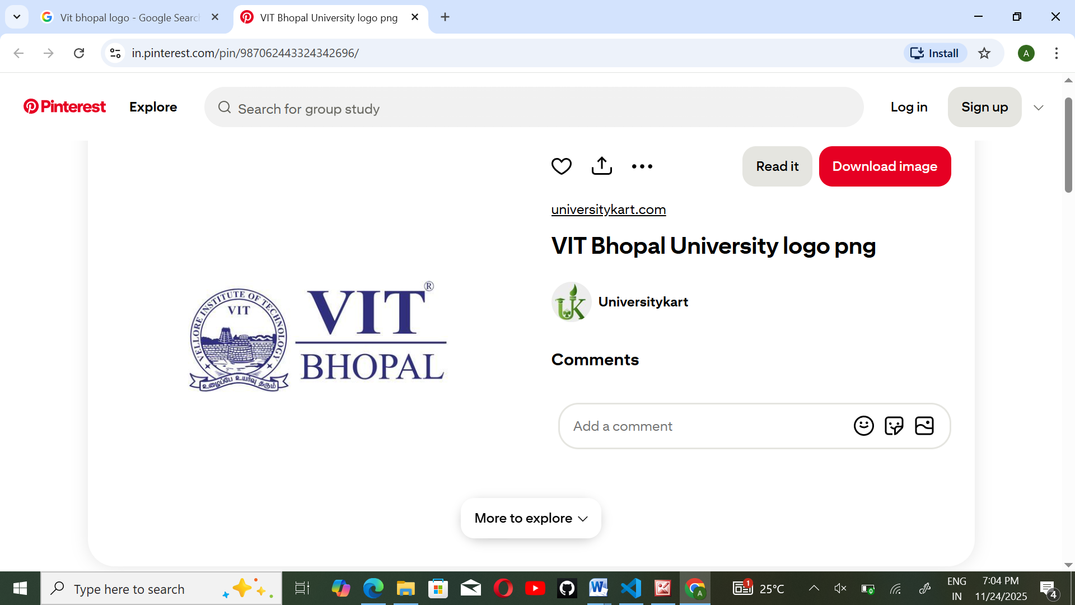
PROJECT REPORT
Digital Literacy

Name : Aboli Gunjal
Branch : CSE(Core)
Year : 1st Year B.Tech
Course Code: CSE0001
Course Title : Digital Literacy
University : VIT Bhopal University

• Introduction
The Digital Literacy Project aims to develop essential digital skills required for academic and professional growth. In today’s digital age, students must be able to use online tools effectively, communicate professionally, and stay safe on the internet.
As part of this project, I completed five different tasks, each focusing on a specific aspect of digital literacy. These tasks included creating an awareness infographic, building a digital portfolio, exploring coding and collaboration platforms, understanding email etiquette, and learning about cybercrime and online safety.
Overall, this project helped me improve my understanding of digital tools and enhanced my ability to use them responsibly and efficiently.

• Task-1:
For Task 1, I created a digital literacy awareness infographic using Canva. The purpose of this infographic was to help students understand the importance of digital literacy in a simple and visually appealing way. The design included three main topics: what digital literacy is, safe internet practices, and useful digital tools for students.
In the first section, I explained that digital literacy refers to the ability to use digital tools and technologies safely and effectively. The second section focused on safe internet practices such as using strong passwords, avoiding suspicious links, and protecting personal information. The third section highlighted useful tools like Google Docs, GitHub, LinkedIn, and Canva that students can use for academic and professional purposes.
While creating the infographic, I found Canva easy to use due to its templates and design elements. However, arranging the content in a clear and organized manner was slightly challenging. This task helped me understand how to present information visually and effectively.

• Task-2:
In Task 2, I built my student digital portfolio by creating and updating profiles on platforms such as GitHub, LinkedIn, and Kaggle. These platforms are widely used by students and professionals to showcase their skills and achievements.
On GitHub, I created a profile README that includes my basic details and learning goals. On LinkedIn, I added my education details, including my current degree and institution. Kaggle was explored as a platform for practicing data science and machine learning skills.
This task helped me understand the importance of maintaining a professional online presence. These platforms will be useful for showcasing my projects, connecting with professionals, and applying for internships in the future. Over the next four years.

• Task-3:
For Task 3, I explored both coding practice platforms and collaboration tools. I created an account on HackerRank and solved a beginner-level problem called “Solve Me First” using Python. This helped me understand how coding platforms work and how to write and test simple programs. It was interesting to receive instant feedback after submitting the solution.
In addition, I created a Google Form titled “Digital Literacy Awareness Quiz” with five questions. This form was designed to test basic knowledge of digital literacy among students. I also linked the form to a Google Sheet to collect and analyze responses.
This task helped me understand how digital tools can be used for both learning and collaboration. Coding platforms will help me improve my programming skills, while tools like Google Forms will be useful for conducting surveys and collecting data in academic projects.

• Task-4:
Task 4 focused on understanding professional email communication and responsible social media usage. I wrote two formal emails: one requesting an assignment deadline extension from a professor, and another expressing interest in a summer internship opportunity. This helped me learn the correct structure and tone required in professional emails.
I also created a social media do’s and don’ts checklist to promote responsible online behavior. Poor digital communication can lead to misunderstandings and missed opportunities. For example, an unclear or informal email may not be taken seriously. This task helped me understand the importance of clear, polite, and structured communication in both academic and professional environments.

• Task-5:
In Task 5, I studied cybercrime, specifically phishing attacks. I learned how attackers use fake emails and websites to trick users into sharing sensitive information. What surprised me the most was how realistic these scams can appear, making them difficult to identify.
This task helped me understand the importance of being cautious while using the internet. Even a small mistake, such as clicking on a suspicious link, can lead to serious consequences like financial loss or data theft. As a result, I will be more careful about verifying links and will avoid sharing personal information online. I will also follow safe practices such as using strong passwords and enabling two-factor authentication.

• Conclusion:
The Digital Literacy Project was a valuable learning experience that helped me develop essential digital skills. Through this project, I gained knowledge about online tools, professional communication, and cyber safety. It also helped me build a strong foundation for creating a professional digital presence. Overall, this project has improved my confidence in using digital platforms and understanding their importance in academic and real-world situations. The skills learned will be useful throughout my academic journey and future career.
• References:
- Canva (www.canva.com)
- GitHub (www.github.com)
- LinkedIn (www.linkedin.com)
- HackerRank (www.hackerrank.com)
- Google Forms (forms.google.com)
- National Cyber Crime Portal (www.cybercrime.gov.in)

